Lead Scoring

Machine Learning 1

Siva Gopavarapu

Manan Sharma

Saheli Paul

# Problem Statement

* Build a logistic regression model to assign a lead score between 0 and 100 to each of the leads which can be used by the company to target potential leads
* Propose the changes which will help to increase the conversion rate
* The CEO, in particular, has given a ballpark of the target lead conversion rate to be 80%.

# Precursor

* The data provided was first cleaned to remove the null values and the outliers
* Then EDA analysis was performed rule out the variables that are less important

# Model

For out use we use the Logistic regression model

For training we split the data into 2 parts train:70% and test:30%.

## Feature Selection

We select top 15 features using RFE to reduce the model load. The top 15 features used for trainging are

* Total Time Spent on Website
* Lead Origin_Lead Add Form
* Last Activity_Converted to Lead
* Last Activity_Email Bounced
* What is your current occupation_Working Professional
* Tags_Already a student
* Tags_Busy
* Tags_Closed by Horizzon
* Tags_Interested in other courses
* Tags_Lost to EINS
* Tags_None
* Tags_Ringing
* Tags_Will revert after reading the email
* Tags_switched off
* Last Notable Activity_SMS Sent

It was found that following features have p value more than 0.5 and hence were removed.

* Tags_Interested in other courses
* Tags_Already a student
* Lead Origin_Lead Add Form

### Multicollinearity Check

The remaining featured were tested for multicollinearity using VIF. The feature with highest score of 1.644171 was

Tags_Will revert after reading the email

Since the score is fairly low the feature was not removed.

### Cutoff

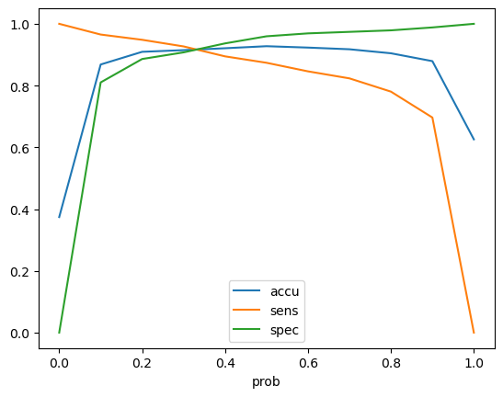For determining the cutoff we compared accuracy, specificity and sensitivity and found it to be 0.3.

## Conclusion

The final results for the model are

Training:

• Accuracy: 91.48%

• Sensitivity: 92.68%

• Specificity: 90.76%

Testing:

• Accuracy: 91.57%

• Sensitivity: 92.11%

• Specificity: 91.24%